# **Name: Abdurrahman Qureshi**

# **Roll No: 210451**

Practical No: 6

**1) Write a program to display 5 students basic information in a table**

**form using Table layout.”**

**CODE:**

<?xml version="1.0" encoding="utf-8"?>  
<LinearLayout xmlns:android="http://schemas.android.com/apk/res/android"  
 xmlns:app="http://schemas.android.com/apk/res-auto"  
 xmlns:tools="http://schemas.android.com/tools"  
 android:layout_width="match_parent"  
 android:layout_height="match_parent"  
 tools:context=".HomePage"  
 android:orientation="vertical"  
 android:background="@color/black"  
 >  
 <TableLayout  
 android:layout_width="match_parent"  
 android:layout_height="wrap_content"  
 android:background="@color/black"  
 android:layout_marginTop="250dp"  
 >  
 <TableRow  
 android:textColor="@color/white"  
 android:gravity="center"  
 >  
 <TextView  
 android:layout_width="wrap_content"  
 android:layout_height="wrap_content"  
 android:background="@color/black"  
 android:text="Marks "  
 android:textColor="@color/white"  
 android:textSize="30dp"  
 />  
 <TextView  
 android:layout_width="wrap_content"  
 android:layout_height="wrap_content"  
 android:background="@color/black"  
 android:text="Roll No"  
 android:textColor="@color/white"  
 android:textSize="30dp"  
 />  
 <TextView  
 android:layout_width="wrap_content"  
 android:layout_height="wrap_content"  
 android:background="@color/black"  
 android:text="Name "  
 android:textColor="@color/white"  
 android:textSize="30dp"  
 />  
 </TableRow>  
  
 <TableRow  
 android:textColor="@color/white"  
 android:gravity="center"  
 >  
 <TextView  
 android:layout_width="wrap_content"  
 android:layout_height="wrap_content"  
 android:background="@color/black"  
 android:text="85 "  
 android:textColor="@color/white"  
 android:textSize="30dp"  
 />  
 <TextView  
 android:layout_width="wrap_content"  
 android:layout_height="wrap_content"  
 android:background="@color/black"  
 android:text="69145"  
 android:textColor="@color/white"  
 android:textSize="30dp"  
 />  
 <TextView  
 android:layout_width="wrap_content"  
 android:layout_height="wrap_content"  
 android:background="@color/black"  
 android:text="qarq90 "  
 android:textColor="@color/white"  
 android:textSize="30dp"  
 />  
 </TableRow>  
 <TableRow  
 android:textColor="@color/white"  
 android:gravity="center"  
 >  
 <TextView  
 android:layout_width="wrap_content"  
 android:layout_height="wrap_content"  
 android:background="@color/black"  
 android:text="73 "  
 android:textColor="@color/white"  
 android:textSize="30dp"  
 />  
 <TextView  
 android:layout_width="wrap_content"  
 android:layout_height="wrap_content"  
 android:background="@color/black"  
 android:text="69134 "  
 android:textColor="@color/white"  
 android:textSize="30dp"  
 />  
 <TextView  
 android:layout_width="wrap_content"  
 android:layout_height="wrap_content"  
 android:background="@color/black"  
 android:text="reaper "  
 android:textColor="@color/white"  
 android:textSize="30dp"  
 />  
 </TableRow>  
 <TableRow  
 android:textColor="@color/white"  
 android:gravity="center"  
 >  
 <TextView  
 android:layout_width="wrap_content"  
 android:layout_height="wrap_content"  
 android:background="@color/black"  
 android:text="84 "  
 android:textColor="@color/white"  
 android:textSize="30dp"  
 />  
 <TextView  
 android:layout_width="wrap_content"  
 android:layout_height="wrap_content"  
 android:background="@color/black"  
 android:text="69126"  
 android:textColor="@color/white"  
 android:textSize="30dp"  
 />  
 <TextView  
 android:layout_width="wrap_content"  
 android:layout_height="wrap_content"  
 android:background="@color/black"  
 android:text="spectre "  
 android:textColor="@color/white"  
 android:textSize="30dp"  
 />  
 </TableRow>  
 <TableRow  
 android:textColor="@color/white"  
 android:gravity="center"  
 >  
 <TextView  
 android:layout_width="wrap_content"  
 android:layout_height="wrap_content"  
 android:background="@color/black"  
 android:text="39 "  
 android:textColor="@color/white"  
 android:textSize="30dp"  
 />  
 <TextView  
 android:layout_width="wrap_content"  
 android:layout_height="wrap_content"  
 android:background="@color/black"  
 android:text="69118"  
 android:textColor="@color/white"  
 android:textSize="30dp"  
 />  
 <TextView  
 android:layout_width="wrap_content"  
 android:layout_height="wrap_content"  
 android:background="@color/black"  
 android:text="nomad "  
 android:textColor="@color/white"  
 android:textSize="30dp"  
 />  
 </TableRow>  
 <TableRow  
 android:textColor="@color/white"  
 android:gravity="center"  
 >  
 <TextView  
 android:layout_width="wrap_content"  
 android:layout_height="wrap_content"  
 android:background="@color/black"  
 android:text="56 "  
 android:textColor="@color/white"  
 android:textSize="30dp"  
 />  
 <TextView  
 android:layout_width="wrap_content"  
 android:layout_height="wrap_content"  
 android:background="@color/black"  
 android:text="69129"  
 android:textColor="@color/white"  
 android:textSize="30dp"  
 />  
 <TextView  
 android:layout_width="wrap_content"  
 android:layout_height="wrap_content"  
 android:background="@color/black"  
 android:text="seraph "  
 android:textColor="@color/white"  
 android:textSize="30dp"  
 />  
 </TableRow>  
</TableLayout>  
</LinearLayout>

**OUTPUT:**

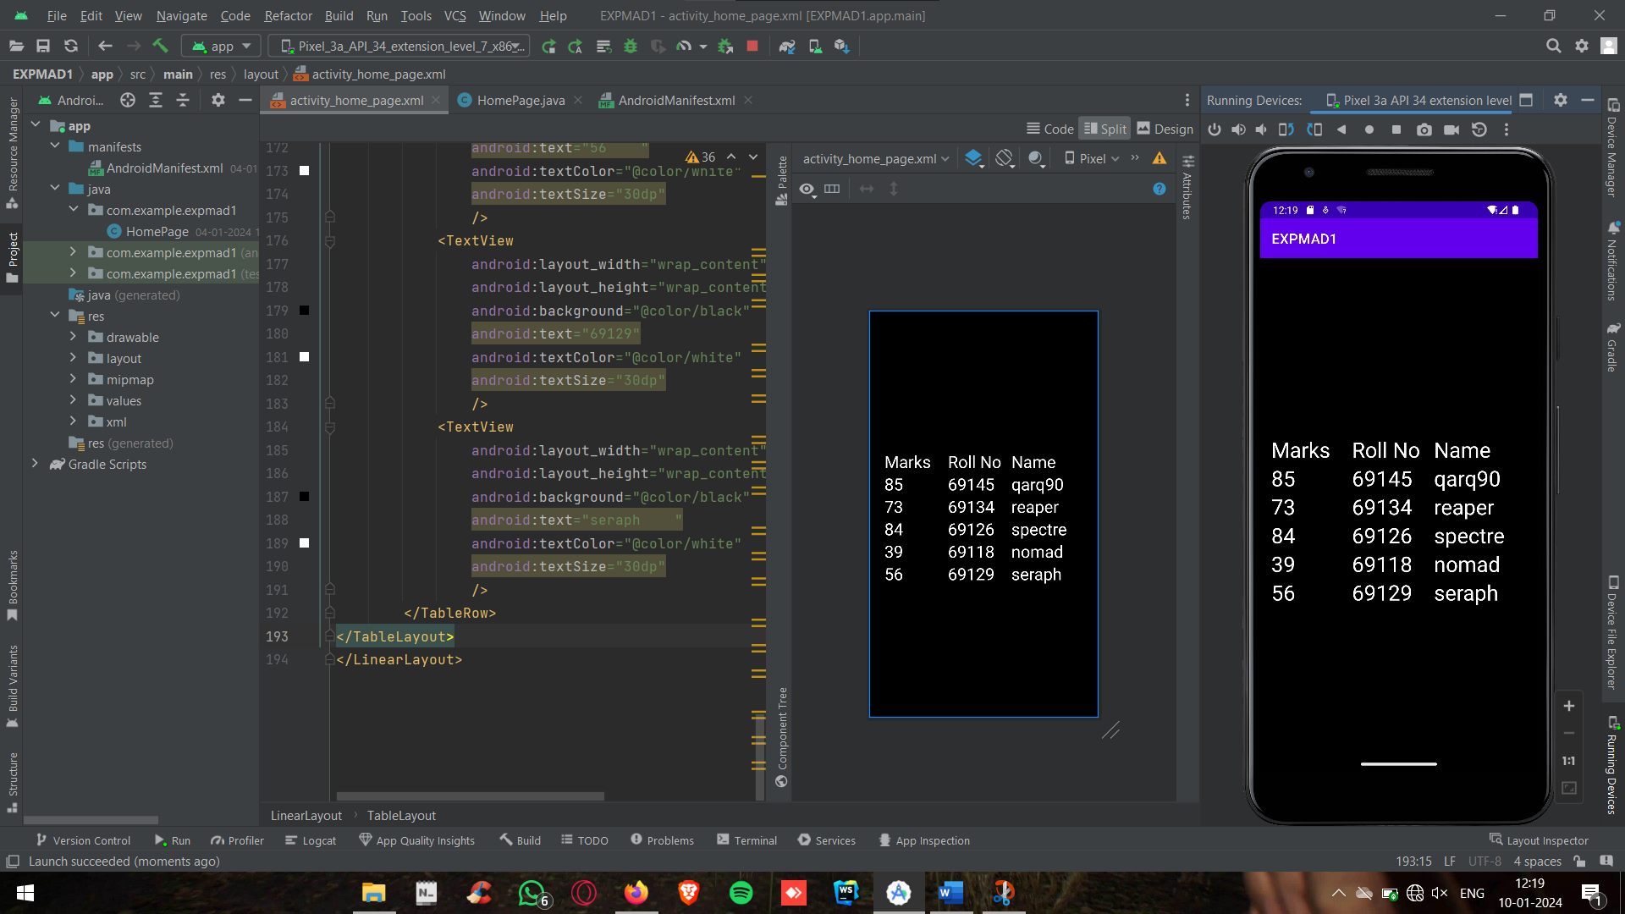

**2) Create the below form using Table Layout.**



**CODE:**

<?xml version="1.0" encoding="utf-8"?>  
<TableLayout xmlns:android="http://schemas.android.com/apk/res/android"  
 xmlns:app="http://schemas.android.com/apk/res-auto"  
 xmlns:tools="http://schemas.android.com/tools"  
 android:layout_width="match_parent"  
 android:layout_height="match_parent"  
 tools:context=".HomePage"  
 android:orientation="horizontal"  
 android:gravity="center"  
 android:background="@color/black"  
 >  
 <TableRow  
 android:layout_height="wrap_content"  
 android:layout_width="match_parent"  
 >  
 <TextView  
 android:text=" "  
 android:layout_width="wrap_content"  
 android:layout_height="wrap_content"  
 android:textSize="30dp"  
 android:textColor="@color/white"  
 />  
 <TextView  
 android:text="Column 1"  
 android:layout_width="wrap_content"  
 android:layout_height="wrap_content"  
 android:textSize="30dp"  
 android:textColor="@color/white"  
 />  
 <TextView  
 android:text=" "  
 android:layout_width="wrap_content"  
 android:layout_height="wrap_content"  
 android:textSize="30dp"  
 android:textColor="@color/white"  
 />  
 </TableRow>  
 <TableRow  
 android:layout_height="wrap_content"  
 android:layout_width="match_parent"  
 >  
 <TextView  
 android:text="Column 2"  
 android:layout_width="wrap_content"  
 android:layout_height="wrap_content"  
 android:textSize="30dp"  
 android:textColor="@color/white"  
 />  
 <TextView  
 android:text=" "  
 android:layout_width="wrap_content"  
 android:layout_height="wrap_content"  
 android:textSize="30dp"  
 android:textColor="@color/white"  
 />  
 <TextView  
 android:text="Column 3"  
 android:layout_width="wrap_content"  
 android:layout_height="wrap_content"  
 android:textSize="30dp"  
 android:textColor="@color/white"  
 />  
 </TableRow>  
 <TableRow  
 android:layout_height="wrap_content"  
 android:layout_width="match_parent"  
 >  
 <TextView  
 android:text=" "  
 android:layout_width="wrap_content"  
 android:layout_height="wrap_content"  
 android:textSize="30dp"  
 android:textColor="@color/white"  
 />  
 <TextView  
 android:text="Column 4"  
 android:layout_width="wrap_content"  
 android:layout_height="wrap_content"  
 android:textSize="30dp"  
 android:textColor="@color/white"  
 />  
 <TextView  
 android:text=" "  
 android:layout_width="wrap_content"  
 android:layout_height="wrap_content"  
 android:textSize="30dp"  
 android:textColor="@color/white"  
 />  
 </TableRow>  
  
</TableLayout>

**OUTPUT:**

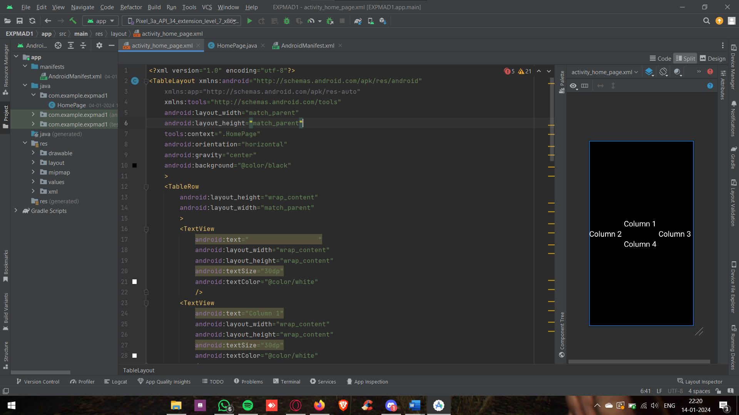

**3) Create the below form using Frame Layout.**



**CODE:**

<?xml version="1.0" encoding="utf-8"?>  
<FrameLayout xmlns:android="http://schemas.android.com/apk/res/android"  
 xmlns:app="http://schemas.android.com/apk/res-auto"  
 xmlns:tools="http://schemas.android.com/tools"  
 android:layout_width="match_parent"  
 android:layout_height="match_parent"  
 tools:context=".HomePage"  
 android:orientation="horizontal"  
 android:gravity="center"  
 android:background="@color/black"  
 >  
 <TextView  
 android:layout_width="match_parent"  
 android:layout_height="wrap_content"  
 android:text="Comms Dept"  
 android:textColor="@color/white"  
 android:textSize="30dp"  
 android:textAlignment="center"  
 />  
 <ImageView  
 android:layout_width="match_parent"  
 android:layout_height="match_parent"  
 android:src="@drawable/download"  
 />  
 <TextView  
 android:layout_width="wrap_content"  
 android:layout_height="wrap_content"  
 android:textColor="@color/black"  
 android:textSize="30dp"  
 android:text="GRADE"  
 android:layout_gravity="bottom||end"  
 android:background="#ccc"  
 />  
</FrameLayout>

**OUTPUT:**

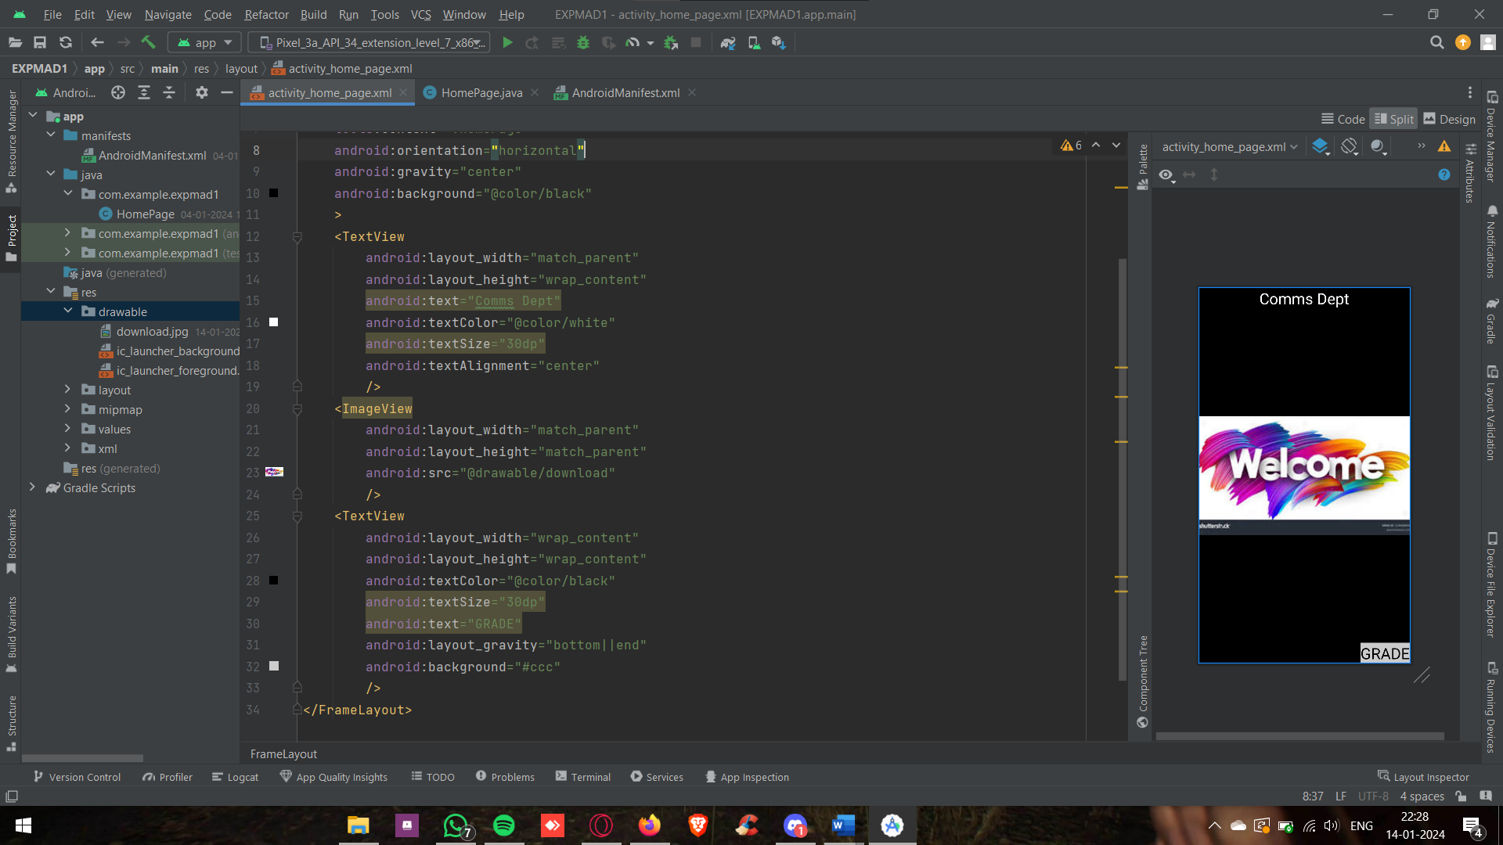

**4) Create the below form using Relative Layout**

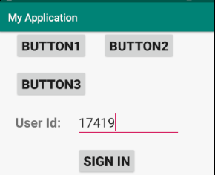

**CODE:**

<?xml version="1.0" encoding="utf-8"?>  
<RelativeLayout class="androidx.appcompat.app.AlertController$RecycleListView" xmlns:android="http://schemas.android.com/apk/res/android"  
 xmlns:app="http://schemas.android.com/apk/res-auto"  
 xmlns:tools="http://schemas.android.com/tools"  
 android:layout_width="match_parent"  
 android:layout_height="match_parent"  
 tools:context=".HomePage"  
 android:orientation="horizontal"  
 android:gravity="center"  
 android:background="@color/black"  
 >  
 <Button  
 android:layout_width="wrap_content"  
 android:layout_height="wrap_content"  
 android:text="B1"  
 android:id="@+id/b1"  
 android:layout_marginTop="-350dp"  
 />  
 <Button  
 android:layout_width="wrap_content"  
 android:layout_height="wrap_content"  
 android:text="B2"  
 android:layout_toRightOf="@id/b1"  
 android:layout_marginTop="-350dp"  
 />  
 <Button  
 android:layout_width="wrap_content"  
 android:layout_height="wrap_content"  
 android:text="B3"  
 android:layout_below="@id/b1"  
 />  
 <LinearLayout  
 android:layout_width="match_parent"  
 android:layout_height="wrap_content"  
 android:layout_marginTop="-120dp"  
 android:id="@+id/upper"  
 >  
 <TextView  
 android:layout_width="match_parent"  
 android:layout_height="wrap_content"  
 android:text="Login Form"  
 android:textAlignment="center"  
 android:textColor="@color/white"  
 android:textSize="30dp"  
 />  
 </LinearLayout>  
 <TextView  
 android:layout_width="wrap_content"  
 android:layout_height="wrap_content"  
 android:id="@+id/emailID"  
 android:text="Email-ID"  
 android:textAlignment="center"  
 android:textColor="@color/white"  
 android:textSize="30dp"  
 android:layout_marginLeft="75dp"  
 android:layout_marginRight="20dp"  
 />  
 <EditText  
 android:layout_width="150dp"  
 android:layout_height="wrap_content"  
 android:textAlignment="center"  
 android:textColor="@color/white"  
 android:textSize="30dp"  
 android:background="@color/white"  
 android:layout_toRightOf="@id/emailID"  
 android:layout_marginTop="50dp"  
  
 />  
 <TextView  
 android:layout_width="wrap_content"  
 android:layout_height="wrap_content"  
 android:id="@+id/pass"  
 android:text="Password"  
 android:textAlignment="center"  
 android:textColor="@color/white"  
 android:textSize="30dp"  
 android:layout_marginLeft="75dp"  
 android:layout_marginTop="50dp"  
 />  
 <EditText  
 android:layout_width="150dp"  
 android:layout_height="wrap_content"  
 android:textAlignment="center"  
 android:textColor="@color/white"  
 android:textSize="30dp"  
 android:background="@color/white"  
 android:layout_toRightOf="@id/pass"  
 />  
</RelativeLayout>

**OUTPUT:**

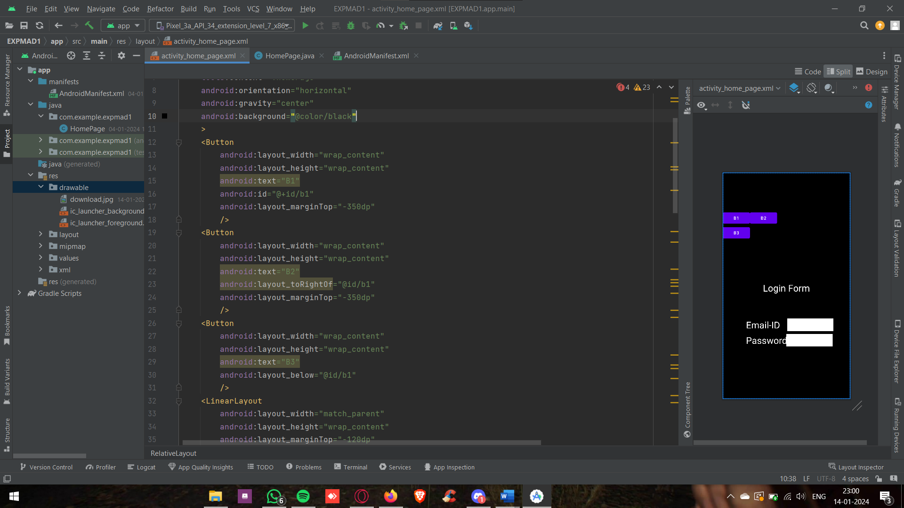

**6) Create the below form using Relative Layout**

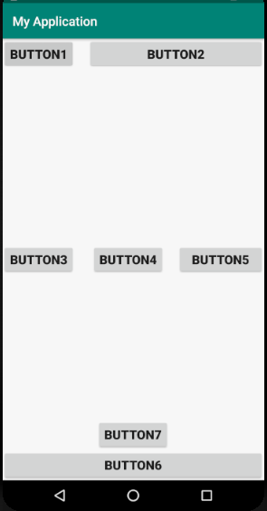

**CODE:**

<?xml version="1.0" encoding="utf-8"?>  
<RelativeLayout android:androidx.appcompat.widget.  
 xmlns:android="http://schemas.android.com/apk/res/android"  
 xmlns:app="http://schemas.android.com/apk/res-auto"  
 xmlns:tools="http://schemas.android.com/tools"  
 android:layout_width="match_parent"  
 android:layout_height="match_parent"  
 tools:context=".HomePage"  
 android:background="@color/black">  
 <LinearLayout  
 android:layout_width="match_parent"  
 android:layout_height="wrap_content"  
 android:layout_alignParentTop="true"  
 android:weightSum="3"  
 >  
 <Button  
 android:layout_width="wrap_content"  
 android:layout_height="wrap_content"  
 android:text="Button"  
 android:textSize="20dp"  
 android:layout_weight="1"  
 android:layout_marginRight="10dp"  
 />  
 <Button  
 android:layout_width="wrap_content"  
 android:layout_height="wrap_content"  
 android:text="Button"  
 android:textSize="20dp"  
 android:layout_weight="2"  
 />  
 </LinearLayout>  
 <LinearLayout  
 android:layout_width="match_parent"  
 android:layout_height="wrap_content"  
 android:layout_marginTop="300dp"  
 android:layout_marginLeft="20dp"  
 >  
 <Button  
 android:layout_width="wrap_content"  
 android:layout_height="wrap_content"  
 android:layout_toTopOf="@+id/bottom"  
 android:text="Button"  
 android:textSize="20dp"  
 />  
 <Button  
 android:layout_width="wrap_content"  
 android:layout_height="wrap_content"  
 android:layout_toTopOf="@+id/bottom"  
 android:text="Button"  
 android:textSize="20dp"  
 />  
 <Button  
 android:layout_width="wrap_content"  
 android:layout_height="wrap_content"  
 android:layout_toTopOf="@+id/bottom"  
 android:text="Button"  
 android:textSize="20dp"  
 />  
 </LinearLayout>  
 <LinearLayout  
 android:layout_width="wrap_content"  
 android:layout_height="wrap_content"  
 android:layout_marginTop="630dp"  
 >  
 <Button  
 android:layout_width="wrap_content"  
 android:layout_height="wrap_content"  
 android:layout_toTopOf="@+id/bottom"  
 android:text="Button"  
 android:textSize="20dp"  
 android:layout_marginLeft="150dp"  
 />  
 </LinearLayout>  
 <LinearLayout  
 android:layout_width="match_parent"  
 android:layout_height="wrap_content"  
 android:layout_alignParentBottom="true"  
 android:weightSum="2"  
 android:id="@+id/bottom"  
 >  
 <Button  
 android:layout_width="wrap_content"  
 android:layout_height="wrap_content"  
 android:text="Button"  
 android:textSize="20dp"  
 android:layout_weight="2"  
 />  
 </LinearLayout>  
</RelativeLayout>

**OUTPUT:**

